**Community Health Worker (CHW) Toolkit:**

**A Guide for CHWs and their Employers**

**Integrating Community Health Workers**

**in Florida’s Health Care Delivery System**

**2022**

www.floridachwCoalition.org

[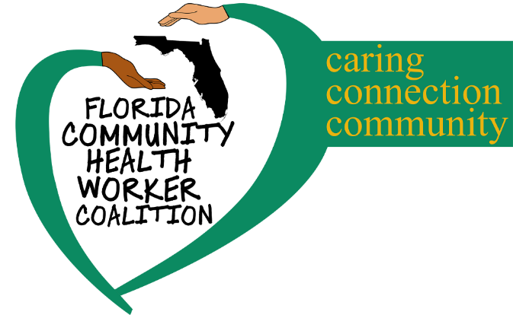](http://www.google.com/url?sa=i&rct=j&q=&esrc=s&source=images&cd=&ved=&url=%2Furl%3Fsa%3Di%26rct%3Dj%26q%3D%26esrc%3Ds%26source%3Dimages%26cd%3D%26ved%3D%26url%3Dhttps%253A%252F%252Ffloridachw.org%252F%26psig%3DAOvVaw2k9MH9PUGAQZmAxyVc2yi2%26ust%3D1573765643694205&psig=AOvVaw2k9MH9PUGAQZmAxyVc2yi2&ust=1573765643694205)

ACKNOWLEDGEMENTS

This 2022 edition of the CHW Provider Toolkit has been adapted from the 2019 edition.

The Florida Community Health Worker Coalition benefitted greatly from the time, talents, and contributions of many individuals who served on the Policy Subgroup and as key informants of the 2019 toolkit. A special thanks to Tenna Wiles, CEO of the Palm Beach County Medical Society Services for her guidance and support. This project was initially supported by the Health Foundation of South Florida (HFSF) under grant number: 18-04973 (2019).

Board of Directors

Florida Community Health Worker Coalition, Inc.

Karen Harwood, MSW, CCM SHRM-CP

Palm Beach County Medical Society, Director of Community Services

Policy Co-Chair, Florida Community Health Worker Coalition

2019 Toolkit Prepared by: Debbie McNamara, Health Management Associates

ii

**Table of Contents**

**(CHANGES REQUIRED AFTER ADVISORY BOARD REVIEW)**

**Community Health Workers in Florida**

**Typical Responsibilities of CHWs in Florida’s Health Care Delivery Systems**

**Who is Employing CHWs in Florida?**

**How are Florida Employers Paying CHWs?**

**Helpful Resources**

***7***

**Attachment 1: Resources for Community Health Workers**

* Quality, Characteristics, and Skills of Successful CHWs
* Why Become a Certified Community Health Worker
* How to Become a Certified Community Health Worker
* Complimentary Certifications and Training

***15***

**Attachment 2: Resources for Employers and Potential Employers of Community Health Workers**

* Consideration of Roles, Skills, and Qualities of CHWs
* Integrating CHWs into your Organizational Structure
* Funding Sources to Pay for CHW Services
* Sample Job Description

# **Community Health Workers in Florida[1]**

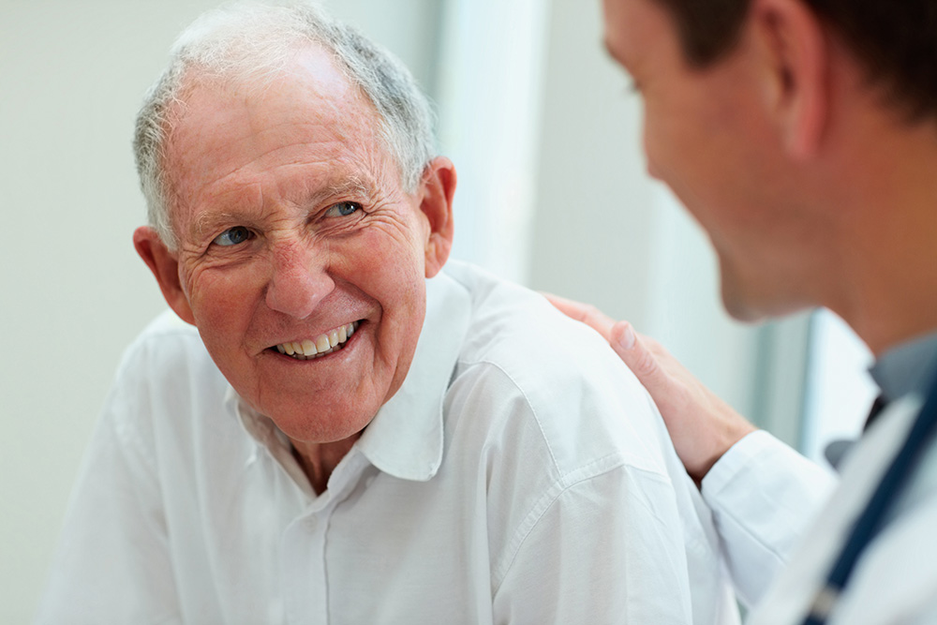Community Health Workers (CHWs) serve as a link between Florida’s communities and health care delivery systems, facilitating access to services and improving the quality and cultural competence of service delivery. CHWs are ***uniquely qualified*** to achieve these goals even among groups that have traditionally lacked access to adequate care because they share the same community, personal, cultural, linguistic, and other characteristics as those they serve.

In Florida, CHWs are working in a diverse array of settings and performing a wide variety of services to help garner better outcomes. CHWs are performing services such as:

* Telephonic and in-person outreach, including targeted education and outreach to defined populations (disease management programs and involvement in appropriate support groups)
* Resource Identification
* Identification and removal of barriers
* Promoting social and physical environments that support optimal health
* Connecting populations to resources that support the system of care
* Support for RNs and Social Workers to manage non-clinical aspects/life circumstances to support overall health outcomes
* Health workshops and condition-specific education (individually and in groups), as well as general education and outreach that promotes preventive care and guides healthy lifestyle choices (including practical life skills, such as teaching food shopping)
* Providing health screenings and assisting targeted patient populations with receipt of timely follow-up exams and tests

CHWs are increasingly being recognized for their powerful potential role in improving today’s health care system, and many ***studies are demonstrating the value of CHW services to improve health care outcomes and reduce costs.***

The Patient-Centered Outcomes Research Institute has recently funded 70 active or completed comparative clinical effectiveness research studies that use CHWs in an intervention. Initial findings from studies reveal that ***CHWs are effectively reducing hospital stays and helping individuals better control chronic high blood pressure and asthma.***[2]

# **Typical Responsibilities of CHWs in Florida’s Health Care Delivery Systems[3]**

The roles and responsibilities of CHWs in Florida’s health care systems vary greatly from outreach to health educator to screener to care coordinator to research team member. The exact mix of these roles and tasks for any one individual varies based on the needs of those served and the provider or organization for which the CHW is providing the service.

Community Health Worker is the umbrella term although CHWs may have other job titles including:

* Patient navigator
* Patient ambassador
* Community health aid
* Promotores de Salud
* Coaches
* Lay, health advisors,
* Community health representatives
* Peer mentors
* Peer navigators

The primary determination about the CHW role is their connection and understanding of the community they serve. The job title can vary, but if the CHW is from the community they serve, they will be better able to navigate overcoming the barriers that low income, disability status, and racial and gender biases create when accessing health care.

**The broad range of competencies that CHWs can bring to an organization is provided in Attachment 2: Potential Employers of Community Health Workers.**

***CHWs Improving Depression and Self-Care Among Latino Patients in Health Clinics, 2013 - 2017***

A research project conducted at three community health clinics in Los Angeles, California between September 2013 and December 2017 found that adding help from bilingual promotoras and community health workers (CHWs) to regular care improved depression and overall health of Latino patients. The Promotoras and CHWs received training in helping patients learn how to manage their diseases, work with their doctors, and know what community resources were available. After 12 months, care from promotoras and regular care that included community health workers helped patients manage their diseases, feel less depressed, have less pain, and have less stress. Clinics can consider using these methods to help Latino patients with depression and other long-term health problems.

*Source: Patient-Centered Outcomes Research Institute;* [*https://www.pcori.org/research-results/2013/working-bilingual-community-health-worker-promotoras-improve-depression-and*](https://www.pcori.org/research-results/2013/working-bilingual-community-health-worker-promotoras-improve-depression-and)

# **Who is Employing CHWs in Florida?[4]**

CHWs are working in a diverse array of settings and performing a wide variety of services across Florida. Organizations currently employing or contracting with CHWs in Florida include:

* Managed Care Organizations
* Hospitals
* Cancer Treatment Centers
* Community Health Centers

***Are you interested in working as a Community Health Worker in Florida or employing a CHW in your organization?***

*Competencies that you should have and/or acquire to be a CHW, or look for in potential employees, are provided in the Helpful Resources section of this Toolkit - see* ***Attachment 1: Resources for Community Health Workers and Resources for Employers and Attachment 2: Potential Employers of Community Health Worker.***

* Rural Health Centers
* Wellness Centers, including Faith-Based Health and Wellness Organizations
* Community-Based Grassroots Organizations

CHWs are performing various roles for providers and other organizations across Florida, including:

* Field-based care coordination work:
  + Supporting discharge planning from hospitals to reduce readmissions and subsequent emergency department visits
  + Health plan management closing care gaps
* Community-baseded education and self-management support ranging from broad health and wellness topics to supporting disease-specific conditions
* Helping certain patient populations with unique cultural needs navigate the health care system (such as Latino and Native American populations)
* Connecting vulnerable populations to clinical and non-clinical services and resources.

*CHWs in Florida are going above and beyond to resolve barriers to care and address a host of obstacles to healthy lives. For example, some CHWs are accompanying individuals to appointments for support and to help establish connections and effective communication with their doctor, visit homes to assess and identify solutions for healthy living conditions, and navigate complex systems to connect patients to needed local resources like food banks.*

***How are Florida employers paying CHWs?[5]***

CHWs who work in Florida are either providing their services on a volunteer basis or are being reimbursed through employer salary/wages or grants, including grants funded through county/taxing districts.

Some providers have been able to obtain Medicare reimbursement for CHW services through the Medicare Chronic Care Management Services program.

Funding CHWs is identified as a challenge that will need to be intentionally addressed through demonstrating return on investment; using workforce-based programs to build capacity and supply, and incorporating the CHW role into other projects/strategies.

**Linking Individuals to Services**

A sole CHW at Genesis Community Health in Boynton Beach achieved great community impact by accomplishing the following in FY 18-19:

* Screened and educated 363 women on breast health; enrolled 91 into the breast and cervical cancer program, and 42 into the Susan G. Komen grant program at GCH.
* Provided basic navigation services for 432 community members looking to establish a healthcare home of which 213 established GCH as their healthcare home.

**CHWs Improving Health Outcomes Associated with Type 2 Diabetes and Cardiovascular Disease**

Project H.I.G.H. (Helping Individuals Get Healthy) was developed to target the priority areas of Diabetes and Cardiovascular Disease for the predominantly African American population of Gadsden County, Florida. Utilizing trained community health workers (referred to as Health Ambassadors), The Road to Health Toolkit (Centers for Disease Control and Prevention, 2008) was used as a model for the community-based educational programs. Within the first month of Project H.I.G.H, nine Health Ambassadors were recruited and trained to conduct the Road to Health (RTH) workshops as well as the New Beginnings one-on-one home visits. The Health Ambassadors provided 170 unduplicated one-on-one home visits to monitor progress with nutrition and physical activity of eligible participants. In year 2 (2014–2015), there was an increase in the number of participants that decreased their BMIs (18–79%).

*Source: Suther, S., Battle, A. M., Battle-Jones, F., & Seaborn, C. (2016). Utilizing health ambassadors to improve type 2 diabetes and cardiovascular disease outcomes in Gadsden County, Florida. Evaluation and Program Planning, 55, 17–26.* [*https://doi.org/10.1016/j.evalprogplan.2015.11.001*](https://doi.org/10.1016/j.evalprogplan.2015.11.001)

**Helpful Resources**

## **Resources for Community Health Workers**

**Qualities, Characteristics, and Skills of Successful Community Health Workers**

Certain qualities and skills are important contributors to the competence of CHWs:[6]

* CHW qualities help to inform who is or becomes a CHW. Qualities are predominantly intrinsic and not ‘taught’, since a CHW comes from the community they serve. When CHWs are recruited, agreement on CHW qualities can help inform a job description and employer decisions.
* CHW skills establish important parameters for the field. Skills inform CHW training and educational decisions.

**A CHW Personally Benefits from her Training**

In 2015, I was given the opportunity to become a CHW trainee with an on-the-job apprentice program conducting needs assessments under the Southeast America Indian Council and the Mission Harvest America organization. Training provided me hands on experience working to identify people at risk, which was very heartwarming to help people. It was also a matter of self-education as I applied the same risk principles of age, race, and a healthy lifestyle to myself and, after noticing symptoms, I took a stool sample to my doctor for analysis. The doctor ordered a colonoscopy, found a growth that was malignant, and removed it before it could reach Stage 2. This early prevention was brought about because of my CHW training and services. It was a God sent blessing to me and further encouraged me of the important work and training of CHWs. I am more determined to complete my CHW certification program and have a compensating zeal to help others understand the risk for cancer and other health disparities and to navigate them to be screened.

*– Shelly McIntosh, CHW and cancer survivor*

Competencies include both skills and qualities. Competencies are “*things that people can do that can be objectively measured – a more flexible, less traditional definition of ‘competency’ is required to fit a flexible, less traditional field.”* Skills are simply “*something a person is capable of doing because they have learned, whereas qualities are personal characteristics or traits that can be enhanced but not taught.*” (Wiggins, 1998)[7]

***Key Intrinsic Qualities and Characteristics of Successful CHWs***

Proficient CHWs are *more likely to establish patient-provider-system trust, and, as a result, improve patient outcomes*[8].

Successful CHWs typically possess the “Three C’s”[9]

* **Community Connectedness** - CHWs know the community and move freely within it.
* **Credibility** - CHWs are known and trusted as leaders and “natural helpers.”
* **Commitment** - CHWs pursue their work out of a sincere commitment to the well-being of the community—because it is their community.

***CHWs apply their unique understanding of the experience, language, and culture of the populations they serve to promote healthy living and to help people take greater control over their health and their lives.***

***Skills that Successful CHWs Should Have or Acquire***

The CHW Core Consensus (C3) Project describes the core **skills** of CHWs as falling into the following categories:

1. Communication skills

2. Interpersonal and relationship-building skills

3. Service coordination and navigation

4. Capacity building

5. Advocacy

6. Education and facilitation

7. Individual and community assessments

8. Outreach

9. Professional skills and conduct

10. Evaluation and research

11. Knowledge base

**Colorectal Cancer Prevention Campaign**

In 2015, the Southeastern American Indian Council worked with CHWs to conduct a needs assessment, provide education to individuals on colorectal cancer risk factors, and arrange screenings. Through an extensive program in Florida, 8% of those who participated were found to have a form of cancer.

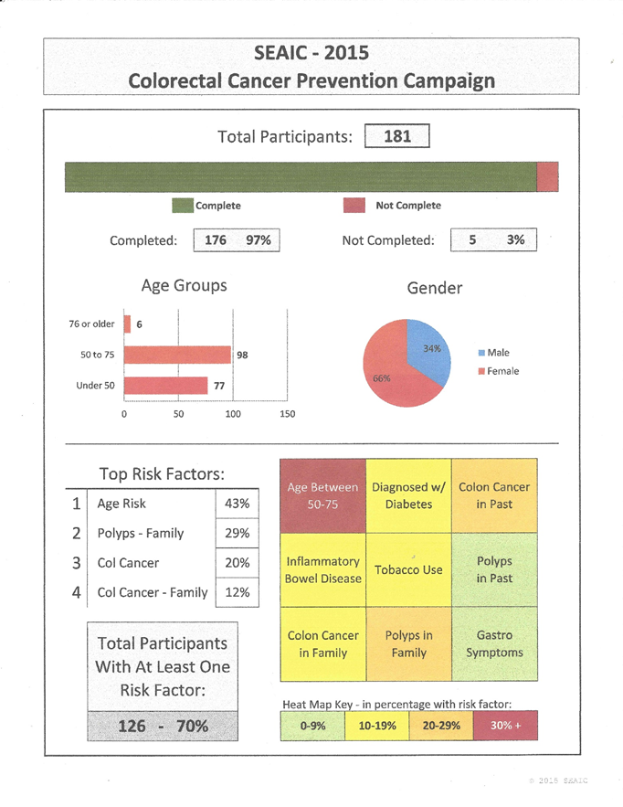

**The value of becoming a Certified Community Health Worker (CCHW)**

***Value of becoming a Certified CHW***

According to a Florida provider who employs 30 CHWs, “*I see [certification] value only because it helps to bridge the work of the community-based organizations and the medical field. Healthcare providers ‘feel’ more comfortable if they are partnering with an organization that [has] certified CHWs. Certifications seem to provide validity to the occupation*.”

Regarding certification, another key stakeholder and public health advocate in Florida notes: “*Organizations will want to know that the people they are hiring have the same degree of ‘training and education’ before they will hire any CHW*.”

***Certification is currently voluntary in Florida***, and therefore you may perform the work of a Community Health Worker without attaining any certification.

Certification will provide you with credentials that may facilitate your ability to find employment. Obtaining the formal certification will provide documented support for your demonstrated competency as a Community Health Worker. The certification will quickly show potential employers what you achieved through training and experience in the performance domains of:

• Communication and Education

• Resources

• Advocacy

• Foundations of Health

• Professional Responsibility

In addition, certification requires ongoing education and re-certification. The certification model ascribes a certain skill set and adherence to an expected code of ethics and informs the work CHWs are qualified to do.

**How do I become a Certified Community Health Worker (CCHW) in Florida?**

Applying for certification is a multi-step process that requires you, the applicant, to submit information and supporting documentation directly to the Florida Certification Board (FCB) and to request documentation from other individuals, which they will need to submit directly to the FCB on your behalf.

Florida CHW Certification Standards and Requirements are summarized in Table 1.

**Table 1. Florida CHW Certification Standards and Requirements**

| Requirement | Minimum Requirement |
| --- | --- |
| Formal Education | High School Diploma or General Equivalency Degree  High School Diplomas or General Equivalence Degrees must be eligible for acceptance by colleges or universities holding nationally recognized accreditation through the United States Department of Education  and/or Council on Higher Education Accreditation (CHEA). |
| Content Specific Training | 30 hours of content-specific training, allocated as follows:  1. Communication and Education: 4 hours  2. Resources: 4 hours  3. Advocacy: 4 hours  4. Foundations of Health: 4 hours  5. Professional Responsibility: 4 hours  6. Electives: 10 hours  Eligible training must be taken from an FCB Approved Education Provider within the last 10 years (no time limit on college coursework taken as part of a degree program). FCB Eligible Training Guidelines and Providers are listed online on FCB’s website www.flcertificationboard.org under Education & Training. Content-specific training and supporting documentation are submitted to the FCB by the applicant. Applicants must complete  (1) The FCB Training Verification Form and  (2) Attach approved supporting documentation for each entry listed on the Form. |
| Related Work Experience | 500 hours of work and/or volunteer experience providing community health worker services in any of the following domains of practice:  • Communication and Education: tasks related to community education • Resources: tasks related to linking community members with available health/social services  • Advocacy: tasks related to advocating for the community’s health/social service needs  Work/volunteer experience must be directly related to the core competencies of the credential and must have occurred within the last 5 years. |
| Recommendations | Three (3) professional letters of recommendation for certification. |
| Exam | Certified Community Health Worker Exam |
| Continuing Education | 10 hours per year. Training content must be related to at least one of the CCHW performance domains as indicated under Content-Specific Training. Continuing Education (CE) credit hours must be non-repetitive (i.e., the same course cannot be claimed more than one time during each credentialed period, even if the course is taken annually). |
| Renewal of Certification | Biennial (every two years), on October 31st of the renewal year |

**Procedural Steps in Florida’s CHW Certification Process:**

**Step 1: Begin the Certified Community Health Worker Application Process**

The *Application for Certification* and supporting documentation will not be assigned to a Certification Specialist for review and action until you have

(1) Created an account in the FCB Online Certification System

(2) Submitted an Application for Certification

(3) Paid the certification application fee.

Applicants should reference the Candidate Guide: Application Process for detailed instructions. This document is located at: <https://flcertificationboard.org/certifications/certified-community-health-worker/>

**Step 2: Examination Process and Credential Award**

The FCB will not allow applicants to register for the exam(s) until their Application for Certification and supporting documents have been submitted and approved. All FCB exams are multiple-choice. FCB exams are administered at approved testing sites across Florida, and in some cases, nationally. The credential is awarded after a passing score is earned on the exam.

When the exam is passed, the applicant becomes a certified professional and enters the maintenance and renewal phase. If you have not completed at least 500 hours of CHW work within the last 5 years, then you will be granted provisional certification and have 12 months to obtain the work experience and achieve full certification.

Applicants should reference the Candidate Guide: Examination Process & Credential Award. This document is located at: <https://flcertificationboard.org/exams/>

**Step 3: Maintenance and Renewal**

Credential maintenance requires you to complete a minimum number of annual continuing education (CE) credits and to follow the FCB’s Code of Ethical and Professional Conduct and Disciplinary Procedures in your daily practice.

Credentials renew biennially, on October 31 of the renewal year. Timely payment of renewal fees and completion of CE documentation is required to prevent inactive status.

Applicants should reference the Candidate Guide: Maintenance &Renewal Process. This document is located at: <https://flcertificationboard.org/maintenance-renewal/>

***Complimentary certifications and training that will support specialized CHW roles***

CHWs have the opportunity to develop career pathways and become ‘specialists’ that focus on a specific role. Evidence supports the involvement of CHWs in the prevention and control of the chronic disease.[10]

***Additional certifications, training, and/or experience working with certain populations are often required or desired by employers.*** For example, additional training and/or certification in Diabetes or HIV/AIDS will enable a CHW to work with this specific population. For example, the Well-Integrated Screening and Evaluation for Women Across the Nation (WISEWOMAN) program in the CDC’s Division for Heart Disease and Stroke Prevention provides low-income, underinsured, and uninsured women with lifestyle programs, screening for chronic disease risk factors, and referral services to prevent cardiovascular disease. In Nebraska, the WISEWOMAN Program is supporting CHW training and certification, as well as special modules that focus on cardiovascular health and screening, including blood pressure monitoring in the community. CHWs are involved in participant recruitment and risk reduction counseling, and they serve as bridges between clinical providers and WISEWOMAN participants.

**Impact of CHWs on Clinical Outcomes for People Living with HIV**

Ninety-one medically indigent persons with HIV with viral loads ≥1,000 and/or a CD4 cell count ≤350 were recruited for a study in Miami. Patients were randomized to a community health worker (CHW) intervention or control group. Compared to the control group, patients randomized to CHWs experienced statistically significant improvements in HIV viral load.

*Source: https://www.ncbi.nlm.nih.gov/pmc/articles/PMC4184095/*

### **Certification and Complementary Education and Training Resources**

Consult the FCB website for available training opportunities:

<https://flcertificationboard.org/education-training/>

## **Resources for Employers and Potential Employers of Community Health Workers**

CHWs bring an array of qualities and skills to employers across Florida. The roles and tasks that CHWs perform vary based on the needs of those served and the employer of the CHW who is providing the service. Roles should be clearly defined to support the qualities the CHW brings, the skills they are taught, and the services they will provide for the organization and population(s) served by the organization.

### **Roles** that employers and potential employers should consider for CHWs to perform include[11]:

* Cultural mediation among Individuals, communities, and health and social service systems
  + Educating individuals and communities about how to use health and social service systems (including understanding how systems operate)
  + Educating systems about community perspectives and cultural norms (including supporting the implementation of Culturally and Linguistically Appropriate Services [CLAS] standards)
  + Building health literacy and cross-cultural communication
* Providing Culturally Appropriate Health Education and Information.
  + Conducting health promotion and disease prevention education in a manner that matches the linguistic and cultural needs of participants or the community
  + Providing necessary information to understand and prevent diseases and to help people manage health conditions (including chronic disease)
* Care Coordination, Case Management, and System Navigation
  + Participating in care coordination and/or case management
  + Making referrals and providing follow-up
  + Facilitating transportation to services and helping to address other barriers to services
  + Documenting and tracking individual and population level data
  + Informing people and systems about community assets and challenges
* Providing Coaching and Social Support
  + Providing individual support and coaching
  + Motivating and encouraging people to obtain care and other services
  + Supporting self-management of disease prevention and management of health conditions (including chronic disease)
  + Planning and/or leading support groups
* Advocating for Individuals and Communities
  + Advocating for the needs and perspectives of communities
  + Connecting to resources and advocating for basic needs (e.g., food and housing)
  + Conducting policy advocacy
* Building Individual and Community Capacity
  + Building individual capacity
  + Building community capacity
  + Training and building individual capacity with CHW peers and among groups of CHWs
* Providing Direct Service
  + Providing basic screening tests (e.g. heights & weights, blood pressure)
  + Providing basic services (e.g. first aid, diabetic foot checks)
  + Meeting basic needs (e.g., direct provision of food and other resources)
* Implementing Individual and Community Assessments
  + Participating in the design, implementation, and interpretation of individual-level assessments (e.g. home environmental assessment)
  + Participating in the design, implementation, and interpretation of community-level assessments (e.g. windshield survey of community assets and challenges, community asset mapping)
* Conducting Outreach
  + Case-finding/recruitment of individuals, families, and community groups to services and systems
  + Follow-up on health and social service encounters with individuals, families, and community groups
  + Home visiting to provide education, assessment, and social support
  + Presenting at local agencies and community events
* Participating in Evaluation and Research
  + Engaging in evaluating CHW services and programs
  + Identifying and engaging community members as research partners, including community consent processes
  + Participating in evaluation and research:
    - Identification of priority issues and evaluation/research questions
    - Development of evaluation/research design and methods
    - Data collection and interpretation
    - Sharing results and findings
    - Engaging stakeholders to take action on findings

Employers should endorse CHW roles, skills, and qualities as they pertain to their organizational needs - specifically the types of populations your organization serves, and the types of services your organization provides.

**Use of Roles. Consider the CHW roles outlined above to help define the scope of practice for a CHW. CHWs are best integrated when recruitment and training are thoughtful and targeted based on the desired role. The employer/organization can then identify well-suited CHWs, in terms of qualities like personality and knowledge base, who are best able to perform the roles.[12]**

* Consider the robust definition and a full range of CHW roles to define a scope of practice for CHW(s) within your organization.
* In practice settings, the range of CHW roles can be used to develop a job description for CHWs in multiple practice settings. In some clinical or community-based settings, various roles may be emphasized or in some cases omitted. It is worthwhile for employers and payers to recognize that even within a narrowly defined set of formal job responsibilities, a CHW may find it necessary to exercise a broader range of roles (activities) in pursuit of successful outcomes at an individual or community level.
* Clear scope of defined roles and practice guidelines can be crucial in building relationships with other professions by helping to define practice boundaries.

**Use of Skills. CHW skills outline the range of potential abilities that are central to CHW’s work in a variety of settings where CHWs work with individuals, families, communities, and within systems.**

* In practice-oriented settings, a primary use anticipated for these skills is to inform the development of CHW training or continuing education, or as a comparison tool to assess the content of a current CHW training or capacity-building curriculum. The skills presented may help organizations that are struggling to develop evidence- and competency-based training, and in deciding whether to require standardized CHW curriculum content.
* Skills standards should consider the full range of skills, and adequate financial support should be made available for training in the full range of skills.
* Important practice and policy debates persist about what constitutes the various skill levels for CHWs, and whether all skills are necessary for CHWs in varied settings such as community-based vs. clinically-based practice.

**Use of Qualities. “Connection to the community served” is a key aspect of CHWs' competence and an essential point in the integrity of CHW practice.**

* In practice settings when recruiting CHWs, qualities most needed for the populations your organization serves, and the types of services you provide, should guide the selection of the most effective CHWs for the roles you need to be performed.
* Positions that are not defined in terms of the qualities should not be considered CHW positions.

***Effectively Integrating CHWs into your Organization[13]***

CHWs tend to be better integrated when they increase organizational capacity by enabling the expansion of care to hard-to-reach target populations. CHWs further increase organizational capacity by assuming responsibilities that other health care professionals are not able to fully undertake due to high patient volume and competing duties, primarily by completing non-medical tasks, including assessment, education, and addressing psychosocial needs.

CHWs work most effectively with other health care professionals when every role on the care team is clearly defined and supervision is in place to prevent burnout and assure the CHW is being assigned suitable work. Other practical steps employers can take to effectively integrate CHWs into their organization Include:

1. Create conditions hospitable to CHWs by communicating with existing health care staff. Build enthusiasm for the CHW role by underscoring the potential benefits of CHWs to existing members of the health care team.
2. Support CHWs with structures that provide adequate supervision and support. To seamlessly fit into the health care team, CHWs also need tools compatible with their work and that of other providers. It is critical to make sure that CHWs can access and use essential workplace tools, especially health IT.
3. Create hospitable workflows. CHWs must be present where providers and patients can take advantage of their services, which could require changes to the spatial layout of clinics or patient movement through the care process.

***Paying for CHW Services***

Funding sources that pay for CHW services include local governments, grants, foundations, and employers. Managed care organizations, hospitals, and health systems are some of the fastest growing areas of employment for CHWs as they attempt to positively impact emergency department diversion and hospital readmission rates.

Some providers have been able to obtain reimbursement for CHW services through the Medicare Chronic Care Management Services program (<https://www.cms.gov/Outreach-and-Education/Medicare-Learning-Network-MLN/MLNProducts/Downloads/ChronicCareManagement.pdf>) or diabetes self-management training (<https://www.cdc.gov/diabetes/dsmes-toolkit/reimbursement/medicare.html>).

Numerous states have applied to CMS for a State Plan Amendment (SPA) that specifies reimbursement beyond CPT codes about health education and the CCM program. The Florida CHW Coalition is interested in working with the AHCA to establish a SPA.

CHWs with dual certification, such as medical assistants, diabetes educators, and HIV counselors, may seek reimbursement for services through typical funding sources for those services.

Sample Community Health Worker Job Description

Compensation: $14 p/hr with benefits; grant-funded temporary position

General Job Statement:

Community Health Workers will primarily be working out in the community with specific target populations. CHWs will work closely with medical providers, primary care teams, and other agencies to improve patient care and outcomes.

Requirements:

• Any combination of 3 years of health/social services experience and/or education

• Verifiable good driving record and reliable transportation

• Background check and fingerprinting

• Bilingual/bicultural (Spanish) encouraged to apply

Key Responsibilities:

• Convey the purposes and services of a program to the user population and the impact that program or service would have

• Help patients develop health management plans and goals

• Follow-up with health management/care plans with both patients and providers

• Coach patients in effective management of their chronic health conditions and self-care

• Assist patient in understanding care plans and instructions

• Document activities, service plans, and results effectively while strictly adhering to the policies and procedures in place

• Work collaboratively and effectively within a team

• Establish positive, supportive relationships with participants and provide feedback

• Help clients in utilizing resources, including scheduling appointments, and assisting with the completion of applications for programs for which they may be eligible

• Assist clients in accessing health-related services, including but not limited to obtaining a medical home, providing instruction on the appropriate use of the medical home, overcoming barriers to obtaining needed medical care and social services

• Facilitate communication and coordinate services between providers

• Motivate patients to be active, engaged participants in their health

• Effectively work with people (staff, clients, doctors, agencies, etc) from diverse backgrounds in reducing cultural and socio-economic barriers between clients and institutions

• Build and maintain positive working relationships with the clients, providers, nurse case managers, agency representatives, supervisors, and office staff

• Continuously expand knowledge and understanding of community resources, services, and programs provided; human relations and the procedures used in dealing with the public as part of a service or program; volunteer resources and the practices associated with using volunteers, operations, functions, policies, and procedures associated with the department or program area, procedures and resources available to handle new, unusual or different situations

• Identify and apply appropriate role definition and skilled boundaries

• Other duties as assigned

1. *Source: Key Informant Interviews and Surveys conducted by Health Management Associates, August - September 2019*
2. *Patient-Centered Outcomes Research Institute;* [*https://www.pcori.org/topics/community-health-workers*](https://www.pcori.org/topics/community-health-workers)
3. *Source: Key Informant Interviews and Surveys conducted by Health Management Associates, August - September 2019*
4. *Source of content provided in this section is based on key informant interviews and surveys conducted by Health Management Associates during the time period from August - September 2019*
5. *Source: Key Informant Interviews and Surveys conducted by Health Management Associates, August - September 2019*
6. *Understanding Scope and Competencies: A Contemporary Look at the United States Community Health Worker Field, July 2016.* [*https://sph.uth.edu/dotAsset/28044e61-fb10-41a2-bf3b-07efa4fe56ae.pdf*](https://sph.uth.edu/dotAsset/28044e61-fb10-41a2-bf3b-07efa4fe56ae.pdf)
7. *Wiggins N, Borbon A. Core Roles and Competencies of Community Health Advisors in the Final Full*

   *Report of the National Community Health Advisor Study: Weaving the Future. 1998;*

   [*http://www.chw-nec.org/pdf/CAHsummaryALL.pdf*](http://www.chw-nec.org/pdf/CAHsummaryALL.pdf)
8. *CHW Core Consensus Project (C3) Project:* [*https://docs.wixstatic.com/ugd/7ec423_c3c4b559904d417e851c5dfb5ab25bc8.pdf*](https://docs.wixstatic.com/ugd/7ec423_c3c4b559904d417e851c5dfb5ab25bc8.pdf)
9. *2016 ASTHO State Technical Assistance Presentation:* [*https://www.astho.org/Community-Health-Workers/CHW-Certification-Presentation-Slides/*](https://www.astho.org/Community-Health-Workers/CHW-Certification-Presentation-Slides/)
10. *Centers for Disease Control and Prevention. (2015). Addressing Chronic Disease through Community Health Workers: A policy and systems-level approach (2nd ed.). (April). Retrieved from* [*https://www.cdc.gov/dhdsp/docs/chw_brief.pdf*](https://www.cdc.gov/dhdsp/docs/chw_brief.pdf)
11. *A Contemporary Look at the United States Community Health Worker Field, Progress Report of the Community Health Worker (CHW) Core Consensus (C3) Project: Building National Consensus On CHW Core Roles, Skills, And Qualities;* [*http://www.chrllc.net/sitebuildercontent/sitebuilderfiles/c3_report_20160810.pdf*](http://www.chrllc.net/sitebuildercontent/sitebuilderfiles/c3_report_20160810.pdf)
12. *Payne, J., Razi, S., Emery, K., Quattrone, W., & Tardif-Douglin, M. (2017). Integrating Community Health Workers (CHWs) into Health Care Organizations. Journal of Community Health, 42(5), 983–990. https://doi.org/10.1007/s10900-017-0345-4*
13. *Payne, J., Razi, S., Emery, K., Quattrone, W., & Tardif-Douglin, M. (2017). Integrating Community Health Workers (CHWs) into Health Care Organizations. Journal of Community Health, 42(5), 983–990.* [*https://doi.org/10.1007/s10900-017-0345-4*](https://doi.org/10.1007/s10900-017-0345-4)